You are the lead process engineer at Kirby’s Processed Cheese Company. A new, cheaper, cheese supplier is being brought in to supply cheddar cheese for your processed cheese line. This new cheese can have moisture anywhere from 33% to 39% targeting 36%.

Your current process for creating processed cheese is as follows. Grind the 240lb cheddar cheese blocks using an extractor. Weigh out the rest of the ingredients. Add those ingredients to the process cheese cooker and heat using direct steam injection to a temperature of 180F and hold for 60 seconds. The steam used is saturated steam at 20 psi. Assume that all the energy comes from condensing steam. The mass of condensed steam used is your condensate factor. The cheese is then sent forward to a chill roller and then to packaging.

The formula for the batch cheese is given below.

|  |  |
| --- | --- |
| Ingredient | Lb formula |
| Cheddar cheese | 70 |
| Water | 12 |
| Condensate | Y |
| Whey | 5 |
| Salt | 3 |
| Disodium phosphate | 1 |
| Sodium Citrate | 1 |
| Annatto | 0.5 |
| 80% Lactic acid | 2.5 |
|  |  |

In order to successfully make the product, the moisture must be in the range of 47% to 50% moisture. Since the product is sold by weight, your boss has told you to increase the amount of moisture as high as possible given your inputs. The specific heat of the cheese is 0.72 btu/lb/f

1. Your task is to design a control system that given a known moisture percentage of input cheese will control the amount of water that should be added to the formula to maximize the amount of moisture in the formula. Assume starting temperature of the combined ingredients but precooked batch is 56F.
2. Due to weather conditions between seasons, the starting temperature of the batch can change from 56F to 70F. Adjust your program accordingly and analyze for 70F.
3. (This one is probably out of scope but an interesting concept) Your moisture measurements have some amount of variation around them due to the inconsistent nature of the test. For example, a piece of cheese that is in reality 36% might read as 35% on your moisture test. This test has a normal distribution with a standard deviation of 0.3% moisture. How would you adjust your program to account for this risk knowing that product outside of your moisture range will be thrown away and a total loss for the company.

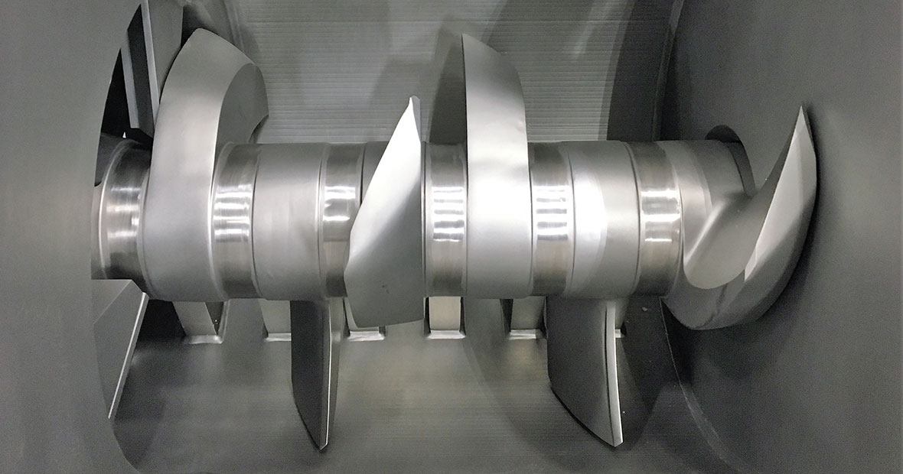

[Cheese Casting Line | Cheese Processing Equipment | HART Design & Manufacturing - YouTube](https://www.youtube.com/watch?v=_-JWyycRO_w)